[NRC Letterhead]

Date: July ___, 2025
To: Citizens of the Town of Wellesley
From: Wellesley Natural Resources Commission
Re: Preservation of the North 40 – Recommended Next Steps
Most of Wellesley’s open space is privately owned. Through the generosity of our founding family (the Hunnewells) and major institutions (e.g., Wellesley College and Babson College), Wellesley benefits from hundreds of acres of intact woodland cleaning our water and air every day.
In comparison to peer communities, however, Wellesley lacks public open space – spaces where kids and adults alike can roam, explore, and recharge in nature. Absent public ownership, the Town relies on private generosity for access, which can change over time (think, for example, of the iconic Wellesley walk around Lake Waban – now prohibited). For this reason, the NRC is passionate about increasing the amount of public forestland, open to the enjoyment of all regardless of status, membership, or affiliation. The NRC is currently working on a Land Conservation Plan to advance this goal, due to be released in late 2025 or early 2026.
However, given the pending decision regarding the placement of a conservation restriction on the North 40, the NRC writes to provide its perspective on the North 40 ahead of the release of the Land Conservation Plan. The NRC’s authorizing statute, §4 of c.555 of the Acts of 1978, directs that the NRC:
…shall study and make recommendations regarding the use, maintenance, management, preservation, and protection of the natural resources of the town which are under the jurisdiction of other boards….
In furtherance of this statutory obligation, the NRC wishes to share our thinking on the proposed conservation restriction and the future of the North 40.

The NRC unanimously concludes that, except for a small area near the old caretaker’s cottage and the existing community gardens, the North 40 should be preserved in its natural, wild, and undeveloped state.

Members’ opinions differ, however, on the best approach for the conservation restriction required as a condition of Community Preservation Act funding. The NRC offers majority and minority reports on that question below.
- Habitat Value of the North 40
In preparing the Land Conservation Plan, the NRC solicited both qualitative and quantitative data to develop a list of priority preservation targets. At public meetings, by far the most public comment the NRC received related to the North 40 and, specifically, its full preservation. While a self-selecting group (presumably, only people with a strong opinion on the topic bothered to show up at our meetings), the NRC notes that it received a large submission of comments for preservation/open space.
More compelling for the NRC is what the data from the Land Conservation Plan show: the North 40 is one of our highest-ranked preservation opportunities. For the reasons discussed above, the Land Conservation Plan primarily focuses on privately held land. However, the data analysis looked at all parcels in Wellesley and applied a score to each parcels based on __ criteria:
- List data set and source here (and relative value)
- List data set and source here (and relative value)
- List data set and source here (and relative value)
- List data set and source here (and relative value)
These data sets were then weighed based on an NRC discussion of their relative values. The map below is a screenshot from the NRC’s draft analysis of the data, with darker colors indicating higher preservation values.
Excerpt from Draft Land Conservation Plan Conservation Value Map
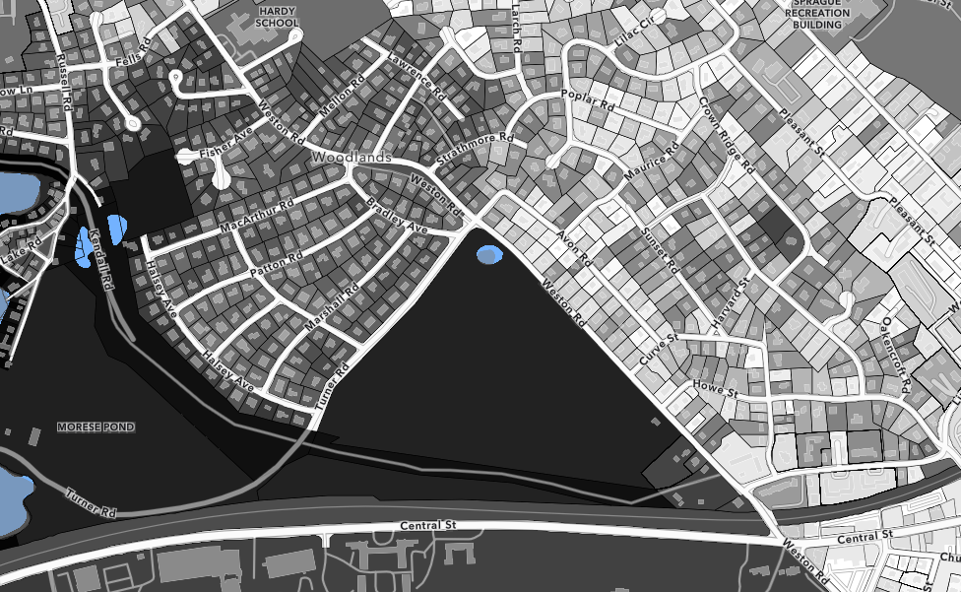
Based on this qualitative and, especially, quantitative data, the NRC recommends that the North 40 be kept in its natural, wild, and undeveloped state, except for an approximately 35,000 sq. ft. area across from Howe St. where the current caretaker’s cottage is, which could be appropriate for housing. The NRC notes that the Town has already removed several large trees from this area, and it is next to The Bristol development. At the discretion of Town Meeting, single-family, duplex, triplex housing may be appropriate in this space, as a buffer between the multi-family zone and the conservation zone.
Potential Housing Opportunity at the Southern End of the North 40
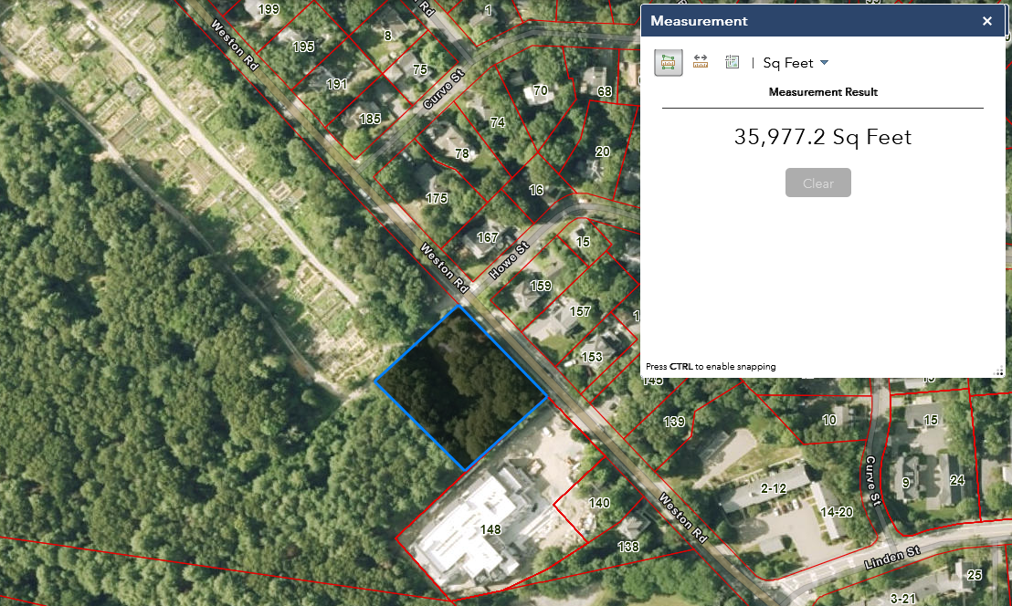
- Conservation Restriction
While in unanimous agreement that the North 40 should be conserved, the NRC is split on the best way to accomplish that goal. There are currently 2 conservation elements that apply to the North 40:
- Pursuant to the June 5, 2015 Deed from Wellesley College, (a) 50% of the North 40 must remain open space in perpetuity, which may include playing fields, wooded areas, paths and trails and other active and/or passive recreational areas and facilities, and (b) the area between Route 135 and the Cochituate Aqueduct must remain in a wooded and natural condition. See Norfolk County Registry of Deeds (Book 33193, Page 405).
- Pursuant to the terms of the Community Preservation Act, a conservation restriction (“CR”) must be executed on the North 40 to cover at least as much of the North 40 purchase price as the Community Preservation Act surcharge funded, which is 28%. There is no timeframe established in the Community Preservation Act to follow through on this requirement. See G.L. c.44B, §12(a).
Pursuant to the terms of Article 2 of the January 20, 2015 Special Town Meeting, Town Meeting authorized the Select Board to decide the portion of the North 40 to be covered by the CR as well as the CR’s specific restrictions. As such, the Select Board does not need to return to Town Meeting for further approvals under the terms of Article 2 as currently in effect.
- Conservation Restriction: [Majority/Minority Report] (List names here)
A majority/minority of the NRC believes that the CR should cover as much of the North 40 as is political possible, and ideally the entire parcel with the exception of the caretaker’s cottage area described above. We reach this conclusion because the North 40 is one of Wellesley’s “natural gems” – irreplaceable in its scale and access. Not only is the North 40 wooded and provides excellent habitat, as the data show, but the North 40 is uniquely accessible among Wellesley’s open spaces. The North 40 sits adjacent to 2 dense neighborhoods in the Woodlands and College Heights, and is easily accessible by Wellesley College students and via the T.
The North 40 also helps protect Morses Pond and the Board of Public Works’ water supply wells adjacent to it. Similar to how Massachusetts Water Resources Authority water from the Quabbin Reservoir requires little filtration prior to consumption due to the broad conservation of the Quabbin watershed, protecting this large piece of the Morses Pond watershed will enhance the quality of both Morses Pond’s as well as our well water.
This majority/minority further believes that these factors will not change – Morses Pond will always be with us and protecting our groundwater will always be necessary. Therefore, we suggest that the conservation restriction cover as much of the North 40 as is politically possible – beyond the minimum 28% – and that the covered area include the highest-value areas of the North 40. To best protect the gem of the North 40, the majority/minority recommend all of the North 40 (except for the caretaker’s cottage area) be placed in the CR.
- Conservation Restriction: [Majority/Minority Report] (List names here)
The majority/minority also believes that all of the North 40 (except for the caretaker’s cottage area) should be preserved, but disagrees that the CR is the best way to achieve that goal. Because we cannot predict what needs the Town will face in the future, the majority/minority recommend limiting the CR as much as legally possible and instead placing a 20- or 25-year deed restriction on the North 40 to prevent development for the foreseeable future, while also recognizing that no one today can predict what the future will hold.
A CR is a legal instrument subject to Article XCVII of the Amendments to the Constitution of the Commonwealth (“Article 97”). In short, Article 97 requires that to use Article 97-dedicated land for non-open space purposes, the General Court must approve such change by a 2/3 vote. Crucially, recent legislation also codified into law longstanding state practice whereby the General Court would not approve removal of land from Article 97 protection unless the city or town replaced such land with unprotected land elsewhere in the community. See Public Lands Preservation Act, now codified at G.L. c.3, §5A. Removing land from Article 97 protection is an intentionally onerous, difficult, and laborious process, the scope and expense of which simply dissuade cities and towns from pursuing removal. This is especially true in dense and developed communities, like Wellesley, where replacement land can be practically impossible to secure. The majority/minority believe putting any more of the North 40 into Article 97 than is legally required is a misstep that will harm future generations’ ability to respond creatively to situations that we cannot imagine today.
We do not have to look back far in Town history to see the impact today of past leaders’ decisions to move land into Article 97. For example, during the protracted Hardy-Hunnewell-Upham debate, the School Committee lacked the ability to consider a significant number of sites in Town as more suitable places for rebuilt elementary schools. During the enrollment decline of the late 1970s through early 1990s, the Town consolidated from 12 elementary schools to 6. The Town then sold off some of these schools (Phillips, Kingsbury, the Brown building) and placed a number of them and other school sites into Article 97 status (Perrin, Bebee, the Brown playground, the Warren playground). While at the time, there was no reason to think the enrollment decline would abate or the population shifts might necessitate a different layout of elementary schools, we know today that was not true. We cannot predict what demands we will face decades more now.
The majority/minority believes that our best option is to make a statement of values today but not to fix in concrete that decision for future generations. As such, the CR should cover as little of the North 40 as is legally possible – ideally, the CR should overlap with the land that is already protected, i.e., the area between Route 135 and the Cochituate Aqueduct as well as the vernal pool. Concurrently, the Select Board should ask Town Meeting to place a 20-year or 25-year deed restriction on the property, to be held by a local conservation organization. (Deed restrictions in Massachusetts can last for up to 30 years, see G.L. c.184, §27, but can be structured to be extended if the democratic process at the time of expiration votes to extend the restriction).

For further information, including the NRC’s 2014–2015 studies and reports concerning the North 40’s acquisition, please visit https://wellesleyma.gov/957/North-40.

